**Discovery Process**

**IVIS19 Project 2**

Joel Weidenmark

950629-4173

joelwei@kth.se

**Research questions**

1. How important are family, friends, leisure time, politics, religion and work in different parts of the world? Can you see any differences based on continent?
2. How do the different variables compare to each other?
3. Random questions: What does life satisfaction look like around the world? Do you prioritise who should work differently around the world? Where in the world are most people religious?
4. Has all these changed over the years?

**Discovery process through WVS**

I wished to look at as many countries as possible

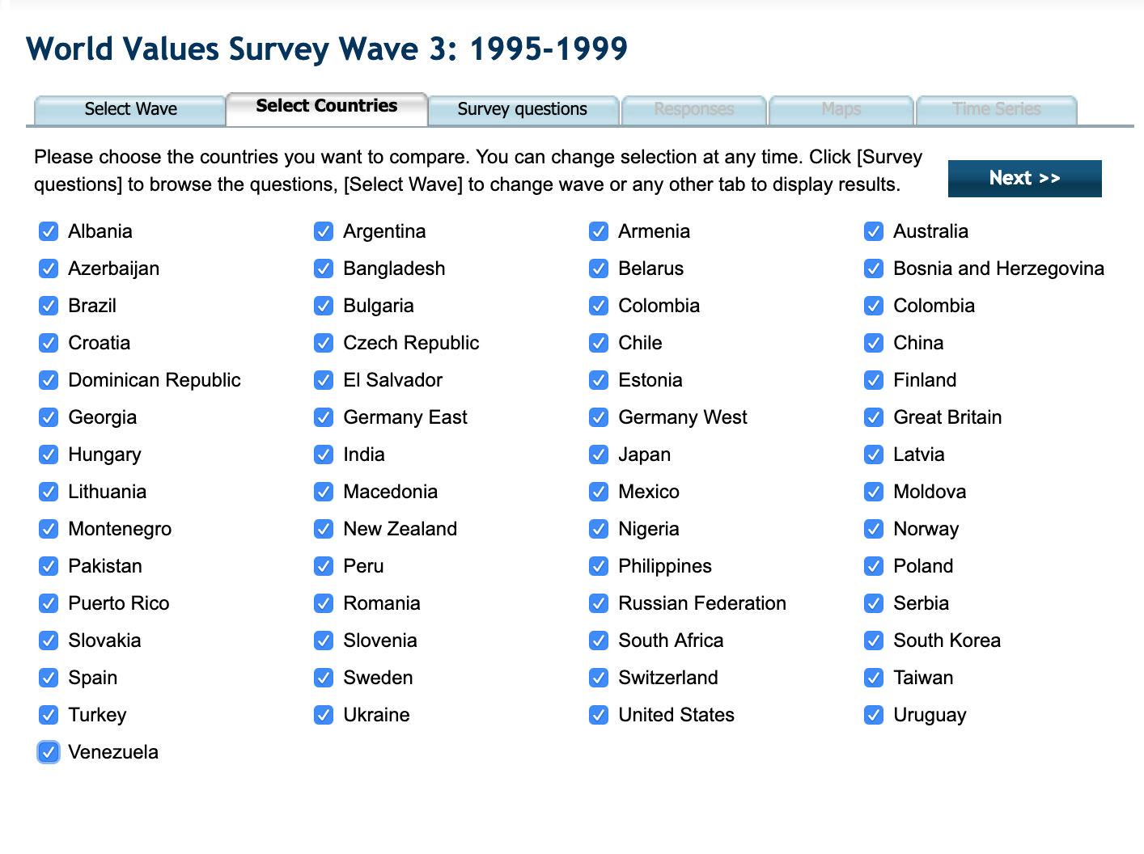

Had to go through them all one by one. Was really hard to compare.

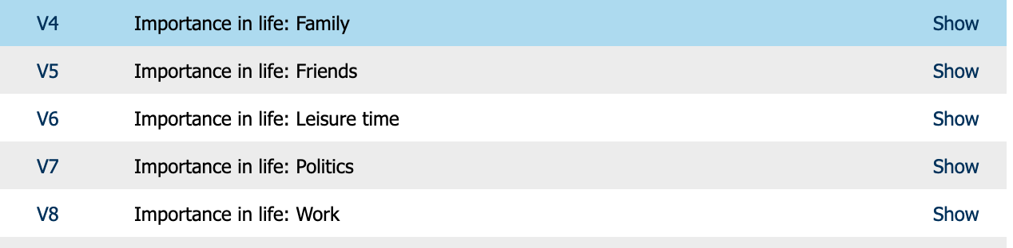

Pretty much impossible to remember and compare different variables. Could cross the different variables.

